Technical Communication Under Linux
A Brief Survey of Tools and Options
Henry Meyerding

Abstract line 1 - 11
Linux has been in the news lately, with a lot of interest in this new platform, but not a lot of useful information. Much of what is available is either hopelessly technical or hopelessly biased or both. The purpose of this document is to provide a general introduction to Linux as it is today, the tools that are readily available for technical communicators, and some of the issues that surround the practical implementation of Linux in a technical documentation workplace.

Preface
Linux has received a lot of media attention recently. As with anything that generates a lot of hoopla, there's a generous quantity of hot air devoted to conveying practically no useful information. Most of what is readily available in the press or on-line is either hopelessly technical, or biased, or both. This overview has three purposes:
1. To describe Linux as it is today.
2. To describe the tools that are available to technical communicators today in Linux.
1. To briefly discuss some workplace issues which will affect your productivity when documenting in Linux.
This is not a sales pitch. This is not a how-to course. This is a brief overview of information about Linux that may be useful for technical writers, editors, web designers, and related professionals. It starts with very basic definitions and then progress to more specific topics.
Reading this overview should clear up much of the mystery surrounding Linux. In order to understand what is presented here, the reader should have a general knowledge of Intel-based personal computers (what used to be referred to as IBM PCs) and experience relating to technical communication using software like Word, Word Perfect, FrameMaker, or similar, in a professional setting. No special technical knowledge is required.
Topics covered:
• The Linux Computer
• Desktop Environment
• Linux Basics for Windows Users
• Documentation Applications
• Cross-Platform Conversions
• Internet Applications
• Graphics Applications
• Groupware Applications
• Other Applications
- Adding Applications and Tools
• Conclusion

The Linux Computer
A computer consists of four things: hardware, operating system, peripherals, and applications software.
Hardware: The most common computer hardware used in technical communication today is the "Intel-based" PC. The term PC is anything but precise definition of specific hardware. Computer manufacturers study a wide range of components and attempt to select components that work well together. They test these components and certify that you can use them with an operating system. There are two operating systems you can buy today that PC manufacturers certify in this way: Windows and Linux.
Operating Systems: Microsoft Windows comes in several flavors: Windows 98, Windows NT, or Windows 2000. Linux comes in many flavors, the most poplar of which are RedHat, SuSE and Caldera.
The term platform means a specific hardware/operating system combination, such as an Intel-based computer with a Windows NT 4.0 operating system, or a Sun UltraSparc computer with Solaris 2.6 operating system.
Many people are confused about the differences between applications and operating systems. A computer can use only one operating system at a time, though it can have many applications. When only the operating system is installed on the computer, it can DO nothing, except install applications. Operating systems usually come with lots of applications, such as the programs in the "Accessories" menu of a typical Windows computer. Different flavors of Linux are packaged with different mixes of applications, such as the SuSE distribution that ships with more than 1500 applications.
Peripherals: Peripherals are extra hardware components that are added to the PC to accomplish a specific task. The most common peripheral is a printer. Others include, modems, scanners, speakers, zip drives, digital cameras, etc.,... Because there are so many different kinds of peripherals, they generally come with a "driver." A driver is a supplemental operating program that allows the computer's operating system to use the added peripheral hardware. Without the right driver for the hardware and specific to the operating system, any peripheral is just a paperweight.
Applications Software: Applications are tools to accomplish a set of tasks: Microsoft Word 2000 is an application that is used to generate documents. Oracle 8i is an application that is used to create databases and manage data. Software is usually developed for a specific platform. The two platforms for which most software is written today are: Microsoft Windows and Linux.
So, what IS Linux? Linux is another operating system designed for the PC hardware and peripherals. It came about when a man named Linus Torvolds was unhappy with the operating systems that were available for computers. At that time, the choice was between UNIX that ran on very expensive hardware that could do everything and Windows 3.1 that ran on cheap hardware and could do practically nothing. Linus wanted something that had the features and functionality of UNIX, without requiring a masters in computer science to install and configure it. He and some of his programmer friends got together and started to write one.
The first versions were really only of interest to serious computer hobbyists, but they gradually improved and the operating system became better behaved. Several companies thought that Linux was a wonderful idea, and spent a considerable amount of time and money making the installation and configuration much easier. Today Linux is a truly global enterprise with tens of thousands of academic and professional developers devoting themselves to the development and refinement of the platform.
There are lots of different "flavors" of Linux out there, but they are all based on the same Linux "kernel." The kernel is the basic guts of an operating system - every operating system has a kernel, even Windows). Almost any Linux you get today comes with a 2.2.x kernel. The difference between each brand is the extra installation software and the mix of applications you can install when loading the operating system. Which flavor of Linux is better is an entirely subjective decision every person must make for themselves
Today, on most new computers, installing Linux requires no more computer savvy than installing Windows. The installation programs auto-detect just about everything, and all you need to provide information unique to your computer: its IP address, the telephone number of your service producer, and so on.
OK, so Linux is just as easy to install and configure as Windows - so why not just use Windows?
This is a very complex issue that many people get very passionate about. People talk about "religious differences" when referring to people who promote a particular platform over another. There are many reasons why some people prefer Linux. Some of them are: development model, cost, tools, mature architecture, true multi-user efficiency, and individuality.
Development Model: There are two software development models currently used in producing the majority of the software proprietary and open source.
Proprietary software is written and owned by a company or individual. You pay the owner to be allowed to use the software and promise to follow the owner's rules of use. If you copy the software or otherwise break the rules, you are breaking the law. This is the way software has been written since the 1950's.
Open source software is written by a person or company and published to the public domain. When it is published, it becomes public property and anyone can use or modify it in any way they want, provided that they make their improvements public. So how do the open source guys get paid? Well, they have a theory: computers don't do anything even with really great software: people do things and computers help them. If you find really great software that promises to make you a lot of money, you will naturally want the people who wrote it to help you realize that promise. As an open source developer, you charge money for these services.
As a user, not a developer, what open source typically means is that if you have a problem, you can contact the person who wrote it and they will actually help you. If that idea appeals to you, you are not alone. For big software packages, where the amount of use precludes this kind of personalized service, there are almost always support groups where you can post a question and get 3-4 answers within a couple of hours.
Cost: Because it is open sourced, Linux has a much lower acquisition cost. Linux also can run on much lower tech equipment than Windows 2000 or even Windows 95. If you really have only $400 and you need to have a computer to do useful work and you do not want to buy pirated software - you have lots of options in Linux and very few in Windows.
Mature Architecture: Linux, as a server, is less stable than industrial strength UNIX, but more stable than Windows. On the desktop, it provides a wealth of applications and services that are the legacy of UNIX. For 25 years, every university computer science organization knew UNIX exclusively. Students and professors ate, drank, and slept UNIX. They did a lot of hacking and found a lot of fixes for a lot of problems. Linux benefits from the legacy directly. So, although Linux is younger than Windows NT, it is also, in a way, more mature
Tools: These same academics write thousands upon thousands of applications for classes, Dissertations, to settle bets, to network with other systems, and every other possible reason. Over the years, this assemblage of code became a core of applications. Some of those applications you might have heard of: TCP/IP, SGML, Perl, FTP, etc.,... The origins of the Internet are UNIX origins. That legacy of really useful stuff runs natively in two places: UNIX and Linux. .
Multi-User Efficiency: You're only one user, why should you care? If the operating system is built on the theory that 200-300 people may be using the CPU to run applications, then it you run 15-20 applications, you will face many fewer delays along the way. Linux hands off to background processes much more than Windows.
Two examples why a multi-user architecture works better:
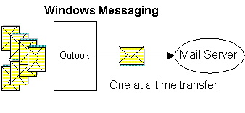
- Write an e-mail message with a big attachment to 200 people in Outlook while working via a modem. How soon after you press the "Send" button can you write another e-mail?
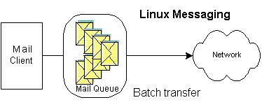
The answer with any of a dozen mail clients in Linux is about 4 seconds.
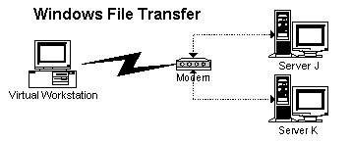
- Two servers at work sit next to one another in a lab. Connect to these two computers from home. Transfer a file from server J to server K. In Windows, the file transfer gets dragged up the line to your computer, through it, and back down the line, passing through the slow modem twice.
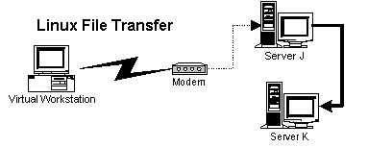
In Linux, it routes the transfer through the fewest hops, passing the data directly between the adjacent servers. The reason this happens this way is because your single-user computer can't delegate the file transfer.
Individuality: Windows does an awful lot of things automatically. Some people like that, others don't. Out of the box, most Linux distributions come almost as automatic as Windows, but this can be changed by an ordinary person in ways that are fully documented. Some people like to shift their own gears.
So why doesn't everyone use Linux? People trust Microsoft. Linux, after all, does not have a marketing budget of $100 million per year. A good analogy would be the American car makers and the Japanese car makers in the late 1960's. In hindsight, it's clear that the Japanese made a much better small car than Chevrolet did in 1969. It just took us 25 years to figure that out. For Microsoft people, only Microsoft will do and there is no argument. The Linux people are just as adamant. It is a complex argument that will not be settled here. It is also perfectly feasible that some other operating system will come along and eclipse both Linux and Windows long before Linux wins any significant market share from Windows. But all this bickering aside, let's assume that Tuesday at 10:00 AM you are told by your employer or contract agency that you will be using Linux. What do you do then?

Desktop Environment
There are basically two kinds of computer interfaces: text interface (ASCII) and graphical user interface (GUI). A text interface is simpler, more robust, and, for most people, pretty limiting. Example of text interfaces include mainframe terminals, DOS, and UNIX. This is also referred to sometimes as the "command line," since the way you interact is to type in text commands following a very rigid syntax. If you can type 220 wpm and never make a typo, then maybe a text interface is for you.
Examples of GUIs include Windows, Macintosh, and Xwindows. Of these three Xwindows is the oldest and the closest to the original GUI from Xerox. Every GUI runs a window manager as well. There is only one Window Manager for a Windows computer, so it works the way it works and you'd better like it that way. Windows 95 and Windows NT are very different operating systems, but they use the same Window manager, so they look and act very much the same.
UNIX and Linux use Xwindows and give you several choices of window manager that make them appear to work very differently. Whenever you start Xwindows, you get whatever window manager is the default choice. In Linux, this is usually either Gnome, KDE, or fvwm. Each one is different, but it all comes down to the same thing: you click on an icon to start an application. Some Xwindows window managers have applications written specifically for them (KDE and Gnome mainly), but most applications work in whatever window manager you choose.
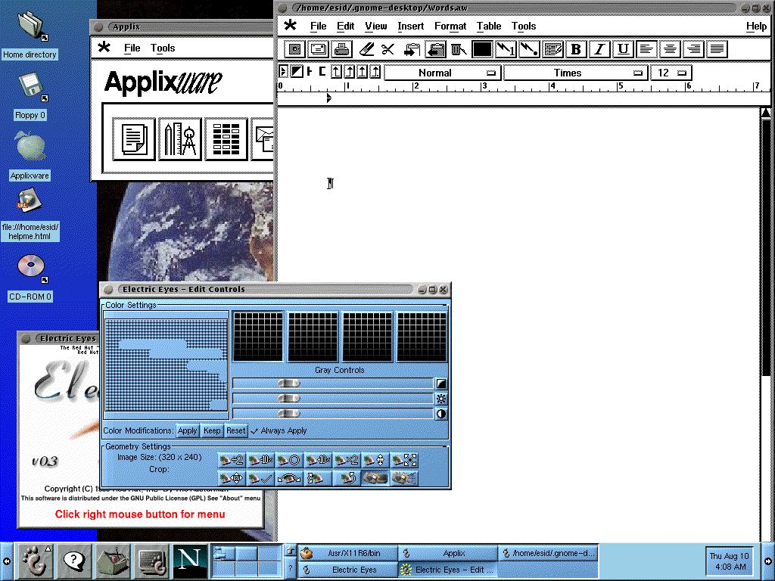
A gnome desktop screen shot

For the purposes of this discussion, we are assuming you have a functioning Linux computer that is already set up and all you have to do is log in. Different people like different window managers. It is NOT necessary to change the window manager in order to be able to be productive - it's just more convenient to work in the desktop you know because it puts things where you naturally look for them.
Your desktop will be configured either to start in Xwindows, or to start in console (text) mode. If it is the former, then you log in and the GUI starts automatically. If the latter, you log in and the system takes you to a prompt. You type startx and the window manager starts and opens the desktop.

Linux Basics for Windows Users
This isn't a good place to learn everything you want to know about Linux, but you will learn a few helpful things that can help keep you from feeling lost.
Each window manager works differently and presents a different working environment (or desktop). Many desktops are very useful as is, but very difficult to configure. If you don't find the tools you're looking for on the desktop, ask someone. Unlike Windows, just because you can't find something does not mean you're ignorant... you may just be very familiar with another Linux flavor or window manager. It is not a sin to ask questions in Linux land.
Most window managers either have a task bar at the bottom of the screen or you can click on an unoccupied area of the screen to cause a menu to display. If the latter is the case, there will almost always be a left mouse button menu and a right mouse button menu. And then there is almost always a three button mouse instead of a two button mouse. And the mouse may "change focus" very differently from the way it does in Windows.
In Windows, whichever window you click on is the window that is active: the focus follows the last click of the mouse. In Xwindows, you get to choose how the active window is defined. You can set it to work like Windows, and many desktops come pre-configured to work like that. You can also configure it so that the focus follows the mouse and whatever window the cursor is over is the active one - with or without becoming the window on top.
The middle mouse button is used when copying text between windows: using the left mouse button, you highlight text on Window A. You can then change to window B and click the middle mouse button and whatever you highlighted is copied to window B.
Linux gives you a home directory. This home directory is your home base on the computer. In your home directory, you can make sub directories, save files, and all the other things you're used to doing as a user. In most of the rest of the computer, you're not allowed to do these things. There is a reason for this. If you don't know what you are doing, you shouldn't be able to do anything that might crash the computer. As an ordinary user, the worst thing you are allowed to do is delete your own files by accident.
UNIX and Linux people have a term for someone doing something stupid or clueless: "he must be running as root." This is a reference to the root login on a UNIX/Linux computer, the administrative login that has no restrictions on what it can do with (or to) the computer. In Windows 95 or 98 every user is root: if you tell the computer to delete everything on the c: drive, it will. In Windows NT or 2000, almost everyone runs with Administrator privileges because it is a real pain to not be able to do anything to your computer (like add a printer). Once you understand that you are a fallible human, you can see the good sense of not "running as root."
If you know the root password on your computer, you can temporarily assume root privileges to do something specific at any time. Once the specific “root task” has been accomplished, you exit from "superuser mode" (if you're smart).
Hard drives are not denoted by drive letters. Instead of mapping a hard drive to a drive letter, Linux uses something called NFS that allows you to seamlessly mount any directory on any network drive as a directory on your local file system. Instead of mounting \\optorg25\cheese\english\cheddar as drive G, you would NFS mount that location and see a cheddar directory now located in your home directory.
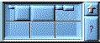
In most Linux window managers, you will see a box at the top or bottom of the screen that is divided into several sections like a tennis court seen from above. Each one of these boxes is a "desktop" where you can have a screen full of applications running. You click on the box you want and it displays whatever is there. In this way, you can have several "real estate intensive" applications open at once and flip between them easily. This is one of the Linux features you will only miss when you're on a Windows computer.
One big difference Windows people find on the command line is that the "\" becomes a "/" in path names. Relative path names look like URLs (/home/pjct/munchkins/98/index.html for example). Another difference is that Linux and UNIX have case sensitive file names.
In Linux, every directory and every file has a set of privileges associated with it. A privilege defines who is allows to read the file, modify the file, or execute the file. Unlike Windows, any file can be executable, regardless of the file extension. There are three classes of privilege holders: the owner, the owner's group, and the rest of the known universe. When something doesn't work the way you expect it to, for example when you find a file is read-only, this usually means you should take a look at the permissions. Find a good UNIX or Linux tutorial about file permissions and read it.
Other than these differences, there is a lot of similarities between Windows and Linux. Linux has several different file managers you can use to view, move, or delete files. There is an increasing list of applications that look and act the same in both Windows and Linux.

Linux /UNIX Basics and Help
http://www.linuxdoc.org/
http://www.ugu.com/sui/ugu/show?help.beginners
http://doors.stanford.edu/~sr/computing/basic-unix.html
http://www.questionexchange.com/servlet3/qx.browse.home
http://slashdot.org/

Documentation Applications
No operating system is worth anything without applications that let you accomplish useful work. In Linux there are several popular office suites available:
• Star Office, recently acquired by Sun
• Applixware by Applix
• Word Perfect Suite by Corel
- Adobe FrameMaker and Acrobat
- Thinkfree Office
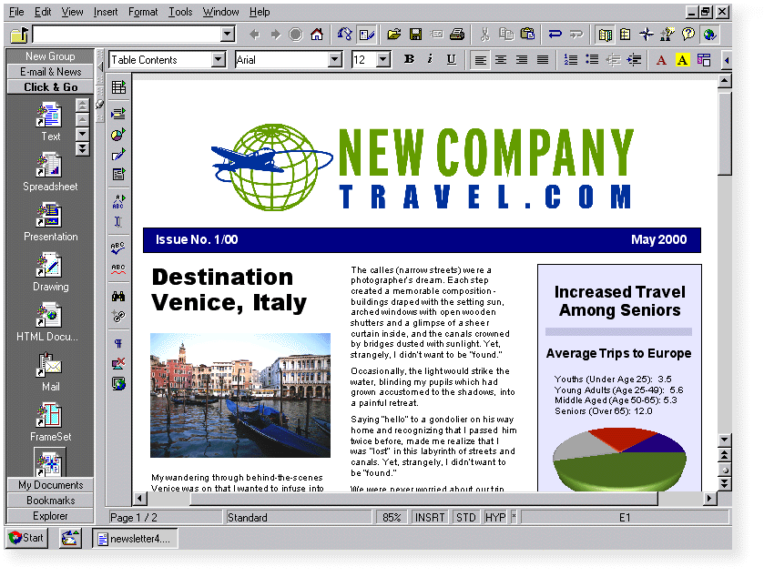
Star Office is available currently free from Sun. It offers the usual range of office applications. They work well and can all read content coming from their Microsoft Office counterparts. They can also export files in a variety of Microsoft and other formats. One advantage to Star Office is that it has both Linux and Windows versions that work very much the same.
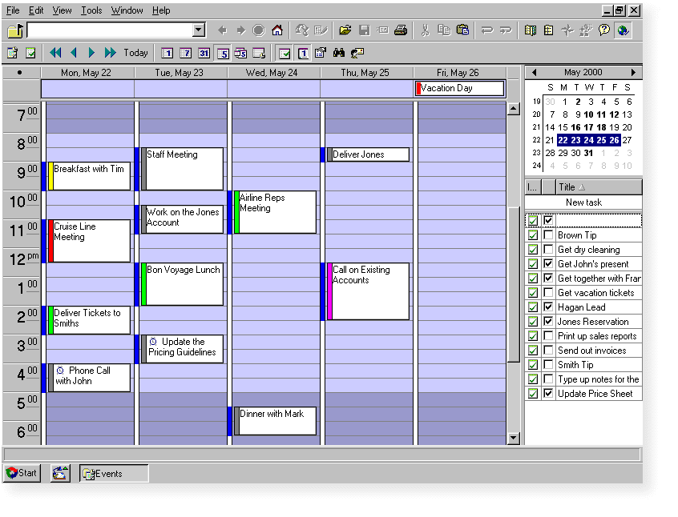
An excellent schedule program is included with the package that is easy and intuitive to use.
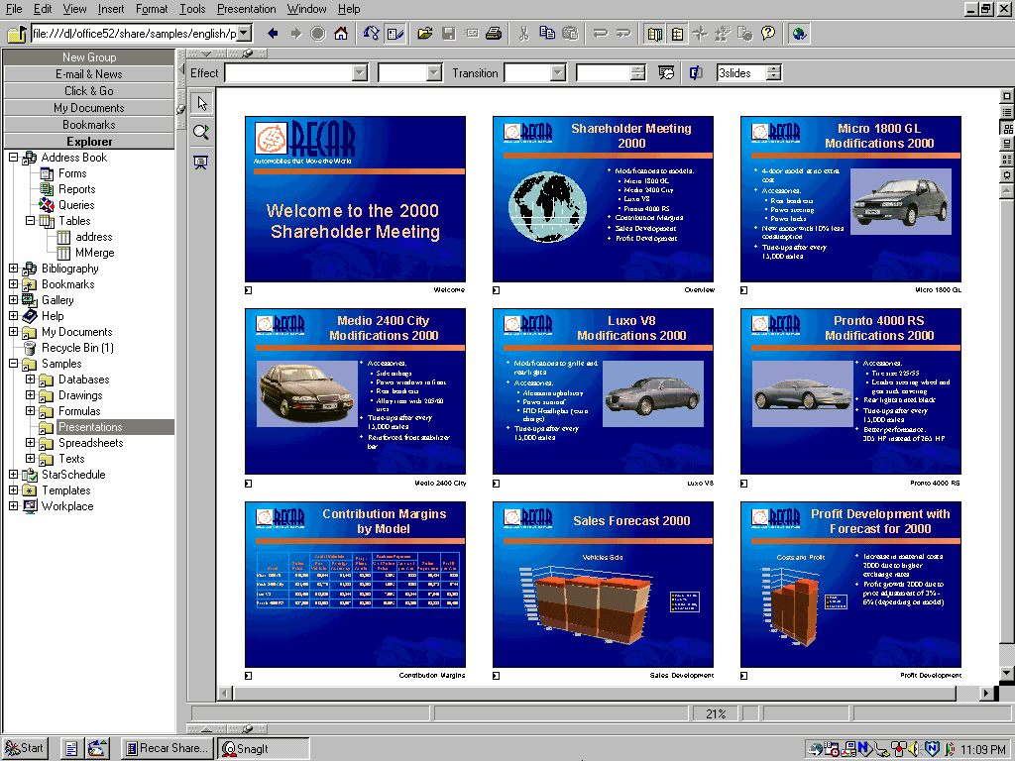
The presentation tool (for Powerpoint) reads Powerpoint presentations well, but is rather difficult to use to modify these files, particularly animation effects. It is also the least stable of the bunch, so save often. The excel tool works very well. The drawing program has its quirks, but can be fun to draw a variety of different illustrations.
Star Office web site: http://www.sun.com/products/staroffice/5.2/features/
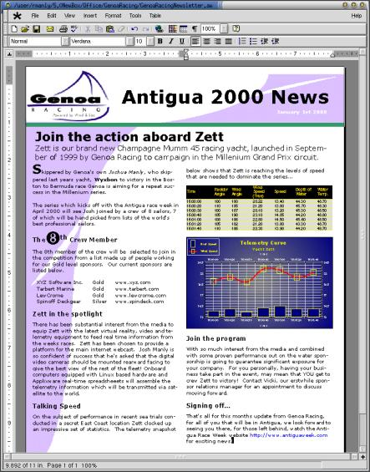
Applixware is an excellent tool. Applixware is a long time UNIX vendor and their products are usually provided in Linux as demos. The demos are usually limited to a single page. You should try these to see if you like them. If you do, then it may be worthwhile to purchase the actual product. Various Linux vendors offer the Applixware office suite for around $80.
Applixware web site: http://www.vistasource.com/products/axware
Word Perfect Office 2000 by Correl is an excellent and robust set of office applications that comes complete with a wide variety of filters for importing and exporting documents. Corel also sells a distribution of Linux, but you don’t have to use their distribution for their office suite to work.
This is the #2 office suite in the world and it has been steadily taking market share away from #1, especially in highly complex markets, such as law offices. The Corel Word Perfect Suite was completely re-written a few years ago and that certainly shows in the crisp and efficient way the applications work and integrate together.
And you get a lot for your money:
- WordPerfect® 9
- Quattro® Pro 9
- Corel® Presentations™ 9
- CorelCENTRAL™ 9
- Paradox® 9 Corel® LINUX® OS (download version)
- Abobe® Acrobat® Reader
- Netscape® Communicator
- Installation Technical Support (30 days) - e-mail and telephone
- Railroad Tycoon II™ - Gold Edition Limited Version** game
- Linux Penguin bean-filled toy

The cost is $100 - 160 depending on the extras.
Word Perfects Office 2000 for Linux web site: http://buy.corel.com/ProductRequirements_id-CC1WA8B84AC.html but don’t look for a lot of screen shots (!).
Adobe FrameMaker is a newcomer to Linux. Adobe has not paid much attention to Linux until very recently when they offered some FrameMaker 5.56 beta releases. These work just like FrameMaker on Solaris. Many people have speculated that when Adobe regularly ports FrameMaker to Linux, that product will quickly become the standard tool for documentation in Linux.
http://www.adobe.com/products/framemaker/fmlinux.html
The only other tool Adobe ports to Linux currently is the Acrobat Reader. It should be noted here that you can print to a file from almost any Linux application to make a postscript file which you can then turn into an Acrobat file with the Acrobat Distiller on a Windows computer.
There are lots of different content creation tools available for Linux, including Tex and LaTex. These are primarily postscript editors which are very useful if you are going to be developing documentation for UNIX only documentation. There are also hundreds of standard tools such as troff, nroff, ghostview, vi, emacs, sed, awk, perl, and so on ad infinitum. These are often referred to as GNU tools or POSIX tools.
Most of the documentation available for UNIX and Linux is distributed either in HTML or as "man pages." There are as many or more tools for the creation and manipulation of HTML in Linux as in Windows. The best place to learn about these tools as they are released is a site specializing in tools: www.freshmeat.net.
There are a variety of interpreters for man pages, but if you are going to produce man page output, I would suggest reading the O'Reilly book on the subject http://www.oreilly .com /catalog/docbook/chapter/book/ manvolnum.html.
Thinkfree Office is a very interesting recent addition to the Linux desktop market . It is a java application clone of Microsoft Office. The applications like Word, Excel, and PowerPoint are very faithfully copied and the applications do an excellent job of making files that are virtually indistinguishable from the files made with genuine Microsoft software. There are clients for Linux and Windows computers and they work almost identically. If the Microsoft Office applications are what you really like, then you might want to look into this free MS-Office clone.

Cross Platform Conversions
A wide variety of filters are available for converting Windows platform (mostly MS Office) formats to and from different Linux tools. The filters provided with Star Office generally work well. Those from Applixware work reasonably well, and also allow a certain about of customization. This can be very nice especially when converting complex documents.
Excel documents usually open well with most Linux applications. There have been some interesting developments lately, especially with the Gnome window manager. The Gnome spreadsheet program does a truly excellent job of converting Excel files. In addition, this tool makes almost flawless HTML exports from Excel, which is more than Excel ever did.
As indicated above, both Star Office and Applixware provide considerable facility to convert files from other formats and to save new compositions in a variety of other formats. In addition, Linux provides extensive text manipulation alternatives with programs like sed, awk, and perl that allow a person who wishes to learn how to use these powerful tools, the ability to perform virtually any document transformation they can imagine.
Word Perfect Office and eSuite from Lotus also have a number of document conversion tools that work very much like those in Star Office and Applixware.
However, none of the automated document conversion applications works well enough for you to work seamlessly in both MS Office and any of the Linux equivalents. These are definitely translations of the native format. Murphy is very active here: when the document conversion must work, it will probably choose that moment to fail or do creative and time consuming things.
This document was written in Applixware, and then saved as an rtf and opened in MS Windows for a final edit.
Although still in Beta stage, the Adobe FrameMaker format is identical to the Solaris (UNIX) FrameMaker format and uses all the same templates. There has been a great deal of experience in moving documents between Solaris and Windows, so there should be no special or unusual issues that crop up for Linux.
Applixware does an excellent job of translating Microsoft Word documents into MIF files for FrameMaker 5.5.6 and 6.0.
Thinkfree Office is said by many to read and write Microsoft Office documents, particularly powepoint flawlessly, but this is a new product and there is no great body of knowledge about successive editing of Microsoft documents, and whether this can destabalize them further.

Internet applications
The Internet is an extension of the basic UNIX client-server protocols. Windows compyters come with software that allows them to interact with the Internet. Over the years, Windows has become progressively better at interfacing with the Internet. Linux computers are intrinsically Internet ready. Linux computers have been gradually evolving better interfaces with non-Internet (ie Windows) networks.
The standard web browser is Netscape, but there are many others, including some text based browsers such as lynx that are excellently adapted for rapid references work on the Internet where graphics content is not needed.
All Linux distributions come with web server software, usually Apache. This allows you to serve web content just by placing the desired files in the proper directories and connecting to a network. Using the hardware that almost everyone will have on their desktops, there is no significant difference in ease of use or performance between Linux as an Apache web server and NT server with IIS.
If you want to do some research, you can always find a wealth of options to support any Internet activity. The hardest part for novices in using Linux in an Internet context is not a lack of suitable applications but rather that there are too many applications to choose from.
A good example of this is CGI, which is commonly used to generate forms and interactive HTML across the Internet. CGI is often used in UNIX/Linux to perform file transformations, and to automate repetitive text operations in Perl - the macro language of UNIX. The best thing about most CGI is that if there is something you want to do, it has probably been written by somebody before, and is probably available for free somewhere on the Internet.
Web browsers are many and varied, and Netscape comes on practically every distribution of Linux, though usually in an older International version and not the newest and greatest. This raises an interesting point: There is almost nothing that you can buy on a Linux distribution CD that is not to be had for free somewhere on the Internet. However, if your Internet connection is slow, you might think the $50-60 extra for a deluxe distribution with lots of applications is a small price to pay if it saves you from dozens of hours of download time.

Graphics applications
The Windows and Macintosh graphics applications are often very expensive and sometimes difficult to use. Luckily for Linux users, there are a wide variety of free and useful tools available.
One of the most useful of these for technical documentation folk is xfig. Xfig is a diagramming and line drawing tool, roughly comparable to Visio. It's mode of operation is completely different from Visio and this can be quite challenging, but experienced xfig users can turn out great quantities of accurate drawings very quickly. Xfig uses its own drawing format but exports to both gif and jpeg for inclusion in web documents.
Another very useful tool is gimp. This is more of an art drawing program, but it has an ever widening variety of tools and widgets available to construct some very elegant and professional looking art. Most documentation folk will be happiest using it to construct copies of icons, to modify screen shots and other simple artwork.
The graphics display tool and screen capture tool of choice is xv for most Linux distributions, although RedHat has favored Electric Eyes, which does approximately the same things.
Both Applixware and Star Office have excellent drawing tools, each with their own limitations and excellent points. Almost every tool you can think of will have an export to gif and jpeg.
There are also some very simple and useful tools like XPaint that is roughly analogous to Microsoft Paint, except that it outputs in gif and jpeg formats (among others) instead of bmp.

Groupware applications
Whatever platform you are working with, being able to communicate and share resources with others is of paramount importance. Linux is a very groupware friendly place to work. There are many different applications that make working with others easy.
Linux has many different e-mail and news clients. It can be somewhat difficult to configure some of them, but your local network administrator will probably find the task of adjusting your chosen client very simple and straightforward.
So many of the applications that are available for Linux have been adapted from UNIX variants and are therefore groupware centric by design. This is in contrast to traditional DOS/Windows applications that have traditionally been developed for a single user on the desktop and gradually adapted for more groupware oriented applications. Group scheduling programs abound, some of which have both UNIX/Linux and Windows clients.
Documentation repositories can be easily and quickly set up in Linux using a variety of different packages, including: Perforce, Clear Case, CVS, and Oracle Document Manager.

Other Applications
There are clients and servers for a variety of databases out there. The most common is Oracle. The databases usually include some tools, though often fewer for Linux than for their commercial UNIX or NT equivalents.
There are a variety of different clients for connecting to network databases. Many of these are very simple and easy to use.
There are lots of different application indexes on the Internet. RedHat, for example, lists the following categories of RPMs that are available from their website:
- Database (35)
- Office Applications & Suites (23)
- Games (9)
- Graphics (16)
- Programming and Development (91)
- Groupware (2)
- Servers (8)
- Math & Science (7)
- Web (1)
- Multimedia (6)
- X Window System (5)
- Networking (43)
- Other (23)
Freshmeat.net currently lists more than 169 categories of applications that represent tens of thousands of applications that are available for the Linux platform.

Adding Applications and Tools
Adding applications can be very challenging in Linux, especially when you do not know what you are doing. At the end of this section are several links to good sources for applications. Most of these will be very difficult or impossible for a novice Linux user to install. The exception to this rule is RPM modules. The RPM format is a self-installing package.
If you are using RedHat and the Gnome window manager, for example, there is a GUI tool called Gnomerpm that is run as root to easily install or upgrade RPM packages. The help for this Gnome tool is almost useful and with a little effort you can find, install and upgrade RPMs easier than upgrading software on a Windows computer.
An important fact to note is that in Linux, just as in Windows, many different applications have dependencies that need to be satisfied. In order to make it simpler to write software, the programmers use "shared libraries" of common code. Having the proper level of the correct shared libraries is a requirement to run an applications - just as you have to have the right DLLs in Windows or your applications won't run. RPMs generally do a very good job, checking for dependencies and curing them, but not always a perfect job. There may be times when you did everything right and it still refuses to work. This is a good time to get qualified help.

Linux Applications:
http://www.redhat.com/appindex/
http://freshmeat.net/
http://www.questionexchange.com/servlet3/qx.browse.showBrowseCategory?for_id=67
http://www.chariott.com/linapps.html

Conclusion
Linux is an operating system that has a wealth of documentation tools and resources available for a very small financial investment. It is an evolving global system making continuous progress towards ease and simplicity of use. In some areas it has a long way to go still.
A Linux platform can be used as an economical personal workstation, or as a network file and web server. It requires very little specialized knowledge to begin using a Linux computer to develop documentation or web content. It does require considerable study and dedication to learn how to use the more powerful features of the operating system. Linux has the power to do anything you can learn to make it do.
REFERENCES & Links
(1) http://industry.java.sun.com/javanews/stories/ story2/0,1072,26928,00.html
(2) http://www.herring.org/techie.html
(3) http://www.li.org/li/resources/papers/ papers.shtml
(4) http://www.caldera.com
(5) http://www.redhat.com
(6) http://www.suse.com
(7) http://www.debian.org/
(8) http://ww.suse.com
(9) http://www.linuxmall.com

Henry Meyerding
Avaya Communication
6464 - 185th Avenue NE
Redmond, Washington 98052
(425) 558-8008 x2252
Internet: hwm@goomba.com

Henry Meyerding is an Instructional Designer for the Education Services group of Avaya Communication, former known as Lucent technologies, in Redmond, Washington. His career in technical communications spans more than 17 years and includes projects for amazon.com, Wall Data, AT&T Wireless, and Microsoft.

